QUE : 1 Open TensorFlow Playground (https://playground.tensorflow.org/) and create a simple neural network with 1 hidden layer and 3 neurons to classify the orange and blue dots. Change the learning rate and observe how the decision boundary changes Hint: Try both a low and high learning rate to see which one converges faster.

- Normal learning rate:
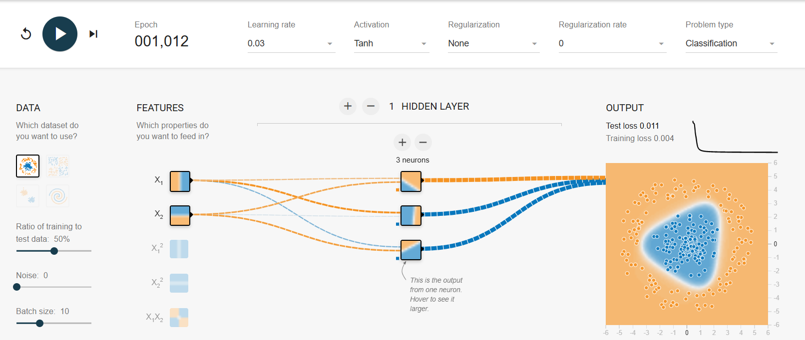

- Low learning rate:

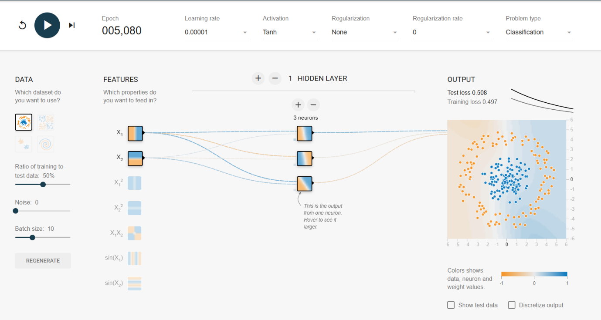

- High learning rate:

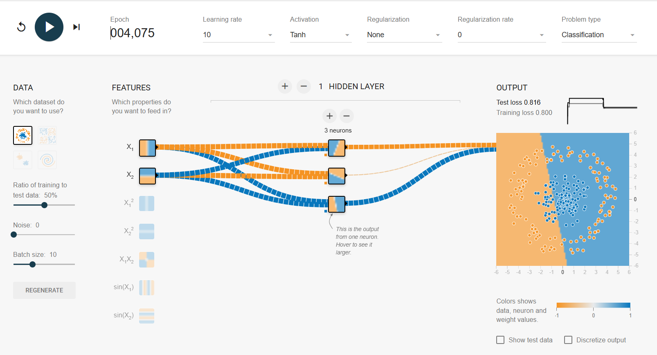

QUE :2 Draw a diagram (on paper or using a digital tool) comparing a biological neuron and an artificial neuron. Label the parts: dendrites/inputs, soma/processing, axon/output, weights, and activation function.

- Biological neuron:
- Artificial neuron:

QUE :3 List 3 apps you use daily (like Instagram, Spotify, or Zomato) and for each, describe one feature that likely uses deep learning. Explain briefly how deep learning could help that feature work better.

Instagram :
- Feature: Feed and Explore Page Recommendations
Deep learning analyzes your likes, comments, shares, watch time, and followed accounts to understand your interests. It then recommends posts and Reels that are most relevant to you, making your feed more personalized.

Spotify:
- Feature: Personalized Music Recommendations
Deep learning studies your listening history, favorite artists, skipped songs, and playlists. It predicts the songs you are most likely to enjoy and creates personalized playlists for a better listening experience.
Zomato:
- Feature : Restaurant and Food Recommendations
Deep learning uses your previous orders, ratings, search history, location, and preferences to recommend restaurants and dishes that match your taste. This helps users discover food they are more likely to order.

QUE:4 Write a step-by-step workflow for building a deep learning model for movie recommendation, starting from collecting user data to deploying the trained model in a real app Hint: Use the stages: Data → Model → Training → Evaluation → Deployment.

1. Data Collection
- Collect user data such as movie ratings, watch history, likes, searches, and browsing behavior.
- Gather movie information such as genre, cast, director, release year, and reviews.
- Store the data in a database for processing.
2. Data Preprocessing
- Remove duplicate or incorrect data.
- Handle missing values.
- Convert categorical data (e.g., movie genres) into numerical format.
- Normalize or scale numerical features if required.
- Split the dataset into training, validation, and testing sets.
3. Model Building
- Select a suitable deep learning model (such as a Neural Network or Collaborative Filtering model).
- Define the input features (user ID, movie ID, ratings, etc.).
- Add hidden layers and an output layer to predict user preferences or ratings.
4. Model Training
- Feed the training data into the model.
- The model learns patterns between users and movies by adjusting its weights using optimization algorithms (e.g., Gradient Descent).
- Train the model for multiple epochs until the prediction error decreases.
5. Model Evaluation
- Test the model using the validation and test datasets.
- Measure performance using evaluation metrics such as Accuracy, RMSE (Root Mean Square Error), Precision, Recall, or Mean Absolute Error (MAE).
- Fine-tune the model if the performance is not satisfactory.
6. Model Deployment
- Save the trained model.
- Deploy it on a web application or mobile app using an API.
- When a user logs in, the model analyzes their preferences and recommends movies in real time.
- Continuously collect new user data and retrain the model periodically to improve recommendations.

